The "D" Spot Redeux
A native Detroiter living, loving, and working in the "D"! Read about Neighborhoods, Things to do and see, Op-eds, Politics, Happenings only in the "D", and Potpourri!

Friday, September 19, 2008

Detroit Jewel: Marcus Belgrave
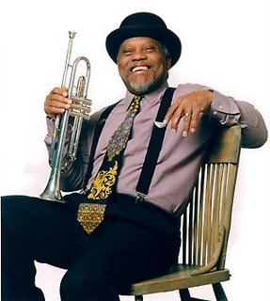
Marcus Belgrave is a Detroit Jewel. He was recently awarded the title of Jazz Master Laureate for the City of Detroit by the Detroit City Council. Marcus Belgrave, a jazz trumpeter in the style of the late Louis Armstrong, has played with all of the jazz greats; including Ray Charles, Wynton Marsalis, Yusef Lateef, Curtis Fuller, Charles McPherson, and Ron Carter. He has also collaborated with Ella Fitzgerald, Charles Mingus, McCoy Tyner, Dizzy Gillespie, Eric Dolphy, Aretha Franklin, and Joe Henderson. He has mentored and recorded with many other musical legends. Although his singing style often brings to mind that of Louis Armstrong, his music covers the entire genre of jazz; from early 20th-century New Orleans, through Swing and Bebop, to contemporary jazz.
But to call Marcus Belgrave "just" a jazz trumpeter is a serious understatement. He is an educator, a composer, an arranger, and a producer. He is also a professor of music at Oberlin University in Oberlin Ohio, and a co-founder of the Jazz Studies Program at The Detroit Metro Arts Complex as well as the Jazz Development Workshop; both in Detroit.
Born in Chester Pennsylvania, Marcus Belgrave moved to Detroit in the mid-1960s to become a staff trumpeter with Motown Records. He was also an original member of the Lincoln Jazz Center Orchestra. Detroit City Councilwoman Joann Watson presented Mr. Belgrave with his award at a ceremony at the Charles H. Wright Museum of African-American History.
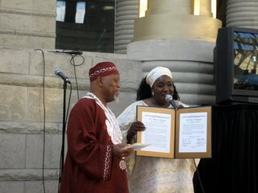
Marcus Belgrave, Jazz Master Laureate for the City of Detroit: a Detroit Jewel.

