I DIG JAZZ
Charles L. Latimer's Jazz Journal

Monday, January 19, 2009

TOGETHER AGAIN
Saxophonist Charlie Gabriel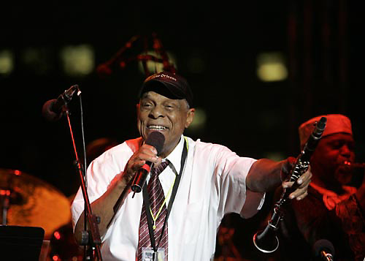

Charlie, what a grand album release party you and trumpeter Marcus Belgrave threw at the jazz club Bert’s Marketplace Sunday evening. The master of ceremony W. Kim Heron, the editor of the Metrotimes, a weekly newspaper based in Detroit, Mi, was right when he compared your partnership with Marcus to saxophonist Benny Golson' relationship with trumpeter Art Farmer.
When I got home, Charlie, I had to soak my feet to reduce the swelling. I stomped my feet all evening. My feet was still dancing during the intermission. It obvious you and Marcus have been making music together for decades. While you guys play selections from your new album “Marcus, Charlie & Joan… Once Again,” I wondered if you and Marcus were conjoined twin separated at birth. You and Marcus have camaraderie.
Marcus did most of the talking. The trumpeter can really work a crowd. If being a jazz musicianship hadn’t panned out, Marcus could’ve been a successful comic. I could listen to him talk about his association with Ray Charles for hours. Several years ago, I had a conversation with Belgrave about Ray Charles. He told me Charles used to pay the band with one-dollar bills. I asked why. Marcus laughed. Then said Charles wanted his band to they’re making a lot of money. Marcus has a thousand stories like that. I bet you have heard plenty of them, and you also have stories to share.
Charlie my favorite moment occurred when Marcus introduced his wife, vocalist Joan Belgrave. The trumpeter joked about has four unsuccessful marriages. Then Marcus said his marriage to Joan has been the best. Joan slipped off her fur coat, (it was little chilly inside Bert’s) her husband took her hand, and she stepped onto the bandstand.
Joan, a self-professed romantic, sang “He Called My Name,” a song she wrote that has become a crowd pleaser. Her voice was hot. If I set closer to the bandstand, her voice would’ve melted me. The only thing that bothered was Joan only sang twice. I could’ve listened to the elegant chanteuse the entire evening without coming up for air. She’s that good. Although she a significant part of the new album, Joan didn’t demand the spotlight. She understood it was Marcus’ gig, and she attended mainly to support him. Joan will have her well deserved moment in the sun in late February. She will release first solo album.
Charlie when you finished soloing on the ballad Violets for Your Furs, the audience eyes were watery. The audience was mostly faithful fans. I wished some of Marcus’ students had attended the party, and witnessed firsthand how accomplished old-time swingers performed captures and audience. Both of you played as if given the secret formula to the fountain of youth.
Charlie, I seen Marcus in various setting with established jazz musicians and students the he helped become topnotch musicians, but yesterday evening Marcus operated and blew on a different frequency. Your running buddy sounded as if pieces of the late trumpeters Louis Armstrong, Fat Navarro, and Clifford Brown spirit’s blessed Marcus’ horn.
The album release was successful. It was neat the way Marcia Walden sit-up the party. The $25.00 cover charge was steep, but I got my money’s worth, including an autographed copy of “Marcus, Charlie, & Joan…Once Again” and all the food I could eat. Actually, the event felt like a big house party. Everybody behaved as if they had a grand time. It was appropriate you and Marcus closed the evening a tribute ditty titled “There’ll Be Some Changes Made,” which you guys dedicated to our new President Barack Obama.
Charlie I bet I wasn’t the only one there who wanted the party to continue. I wanted an encore. You know, jazz fans are greedy. I hope I have as how fun listening to “Marcus, Charlie & Joan…Once Again” as I had hearing you guys live.

