Detroit's Jazz 'Patriarch' Improvised A Teaching Career

by PATRICK JARENWATTANANON – NPR JAZZ 8/29/2012
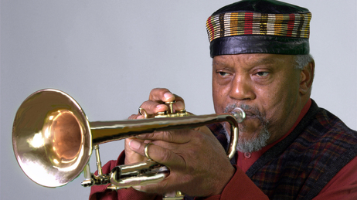

Marcus Belgrave will be featured at this weekend's Detroit Jazz Festival.
There's a lot of astounding information in this comprehensive profile of trumpeter Marcus Belgrave, "the reigning patriarch of Detroit jazz." After touring with Ray Charles for years, and getting opportunities with Max Roach and Charles Mingus, Belgrave opted not to stick it out in New York like many musicians of his caliber. Instead, he chose Detroit, where he's been since 1963.
Belgrave is still performing and recording, in spite of chronic lung disease which keeps him under oxygen all the time — and regularly lands him in the hospital. In fact, doctors have told him that practicing the trumpet so much has actually kept his lungs in working order.
What I find most interesting about this story, written by Detroit Free Press music writer Mark Stryker, is Belgrave's legacy as a teacher. His students include Geri Allen, Kenny Garrett and Regina Carter, to name a few international-scale bandleaders. I think it sheds a little light on how jazz is and can be transmitted.
Belgrave has always had to improvise his own teaching career, starting his own Jazz Development Workshop and bouncing from post to post throughout Detroit and the Midwest. And his formal lessons may not appear to be that formal to the untrained eye. Stryker follows him to a clinic with a "small group of high school and college students":

The rehearsal was supposed to start at 1, but Belgrave, wearing a jaunty leather cap and olive-brown paisley vest, arrived at 1:15 — punctuality has been a lifelong quest. "Y'all have to excuse me for being tardy," he said a bit sheepishly, removing his trumpet from its leather case.
Belgrave called up "Cool Eyes," a hip and swinging bebop tune by Horace Silver with a lickety-split melodic line and cagey rhythms lying in wait. Belgrave set a deliberately slow tempo and played through the melody with the students. There were lots of mistakes. He said little but kept playing the song with them over and over. Each repetition brought greater clarity as the students' awkward attack slowly began to mimic the fluency and feeling of Belgrave's phrasing.
He never talked down to the students; he treated them like fellow musicians. "Put that accent on the upbeat," Belgrave said. "I want the notes to sing; I want them to have a beat to them."
Jazz is an aural art, and Belgrave was teaching the language by ear. An academic watching the scene might have complained about the lack of structure: But he's not really teaching them anything.
Yet the reality is he was teaching them everything.
While he's done a lot in the classroom, Belgrave also ushered his greatest students onto performance stages, often with his own band. That's "where the true education takes place," Stryker writes. It's hard to imagine that Belgrave's greatest students wouldn't agree.

