Marcus Belgrave is the Door to Jazz

Top of Form

Bottom of Form
Top of Form
Bottom of Form
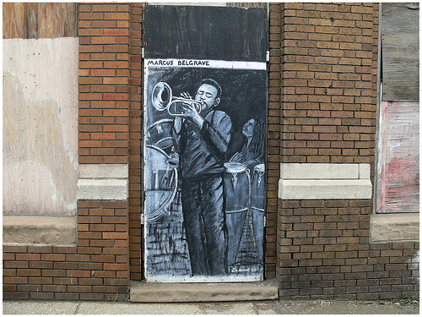
Top of Form

Bottom of Form
Someone has taken an abandoned building on busy Gratiot Avenue, right near Downtown Detroit, and put 4 paintings in the doorways of an abandoned building. These were put here in 2005, but the bad thing is as of November 2008 they were taken down for some reason.

